Experiment 7: Configure a local Kubernetes cluster using Minikube and deploy an Nginx Pod using a YAML file.
Kubectl: is command line tool for Kubernetes where we can directly interact with Kubernetes
Minikube: is a local Kubernetes cluster

Before that start the docker desktop engine
Step 1: Minikube installation
Go to bowser type minikube installation
https://minikube.sigs.k8s.io/docs/start/?arch=%2Fwindows%2Fx86-64%2Fstable%2F.exe+download
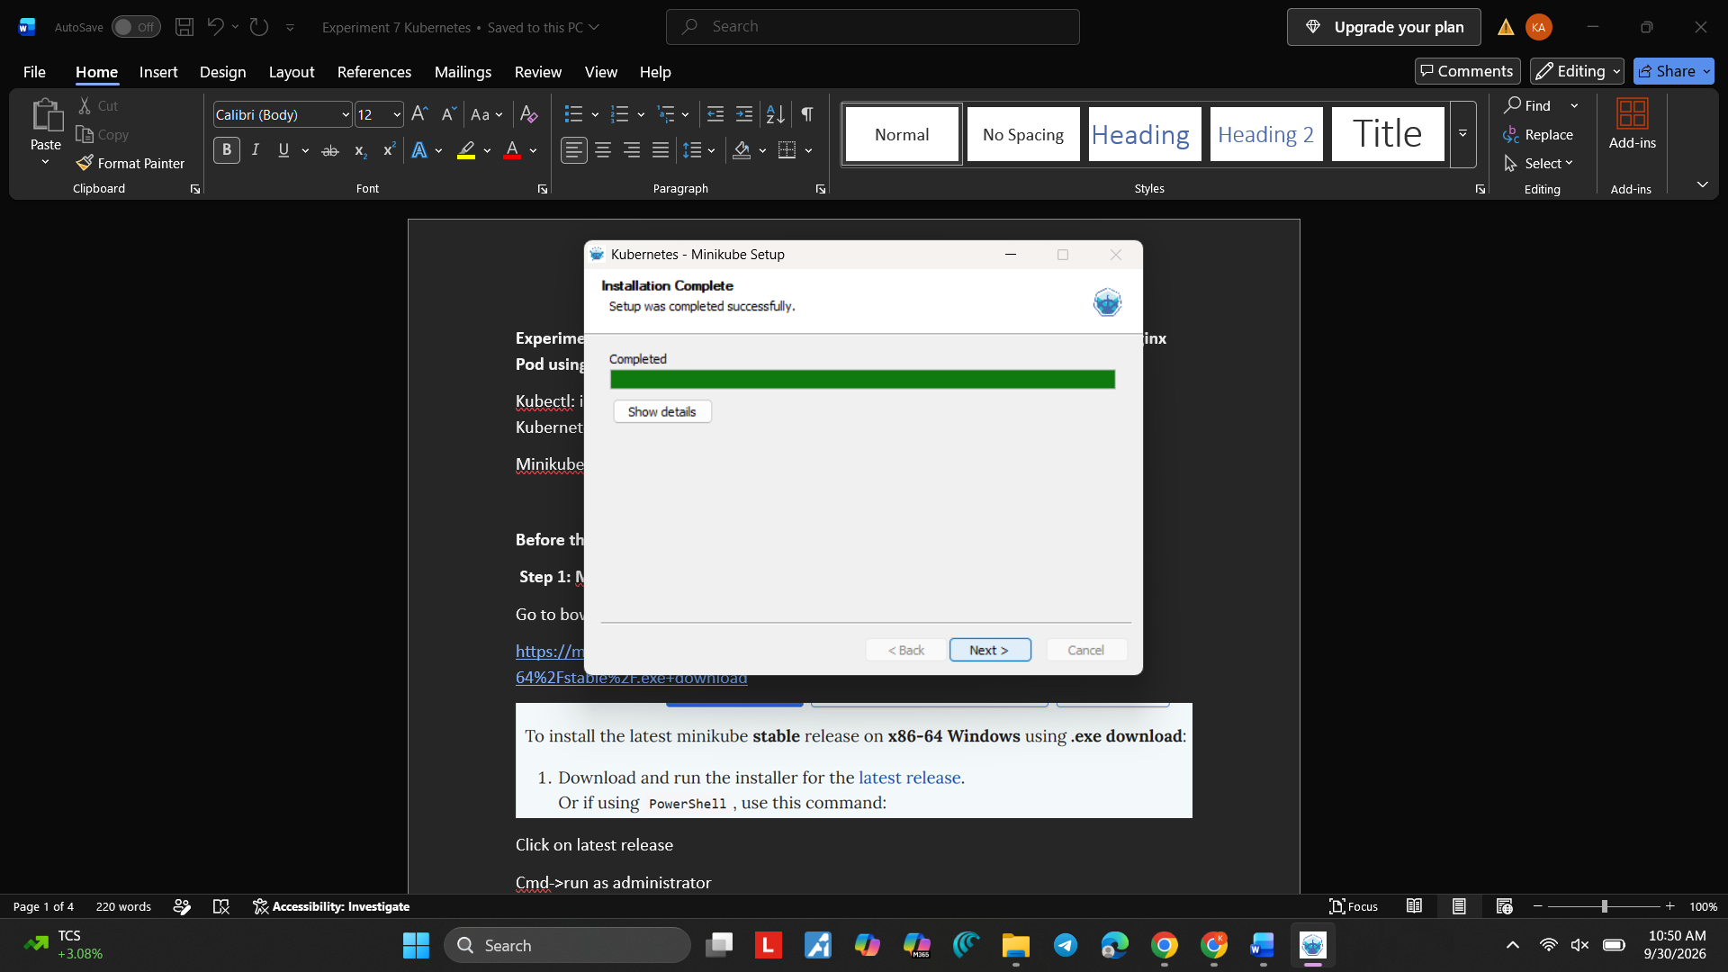
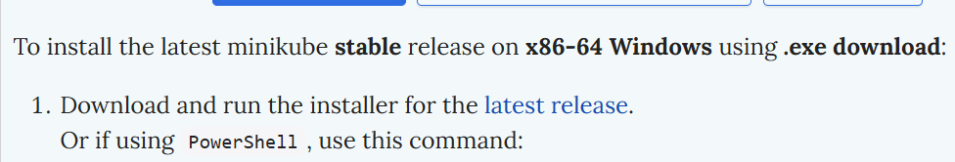
Click on latest release
Cmd->run as administrator
>minikube
>minikube start --driver=docker
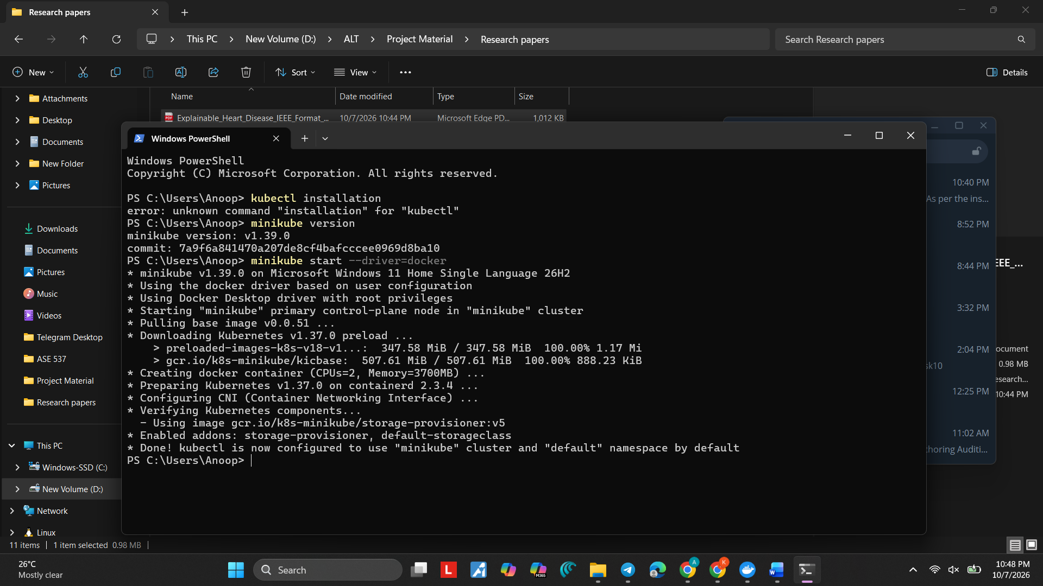
>minikube status
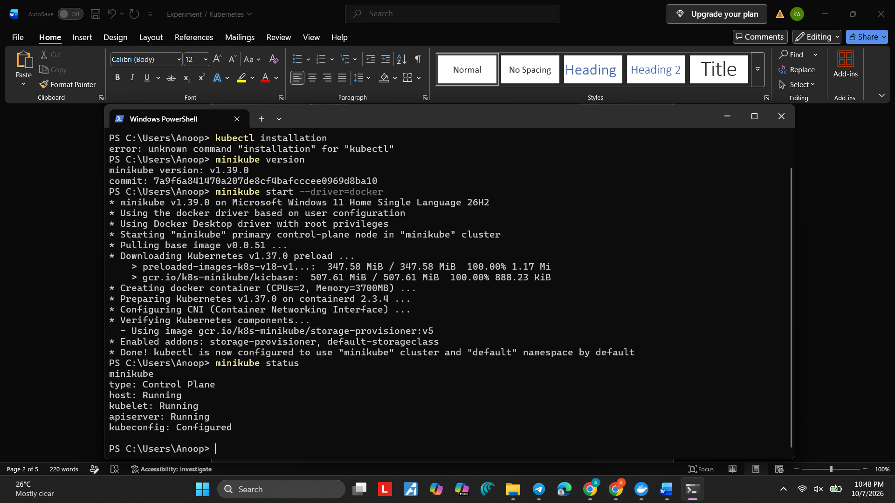
If you get the error for the above commands
minikube stop
minikube delete
minikube start --driver=docker
OR
minikube delete
docker version
docker info
minikube start --driver=docker

Step 2: Installation of Kubectl
Type kubectl installation-->click on install tools-->choose platform
https://kubernetes.io/docs/tasks/tools/install-kubectl-windows/
Copy the Curl and paste in the cmd
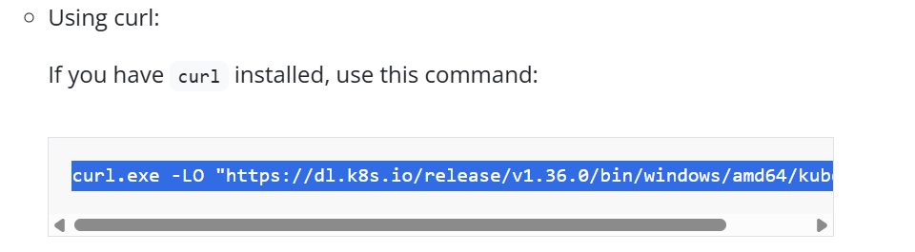
>kubectl version
Check whether kubectl is connected with minikube by the command
>kubectl get nodes
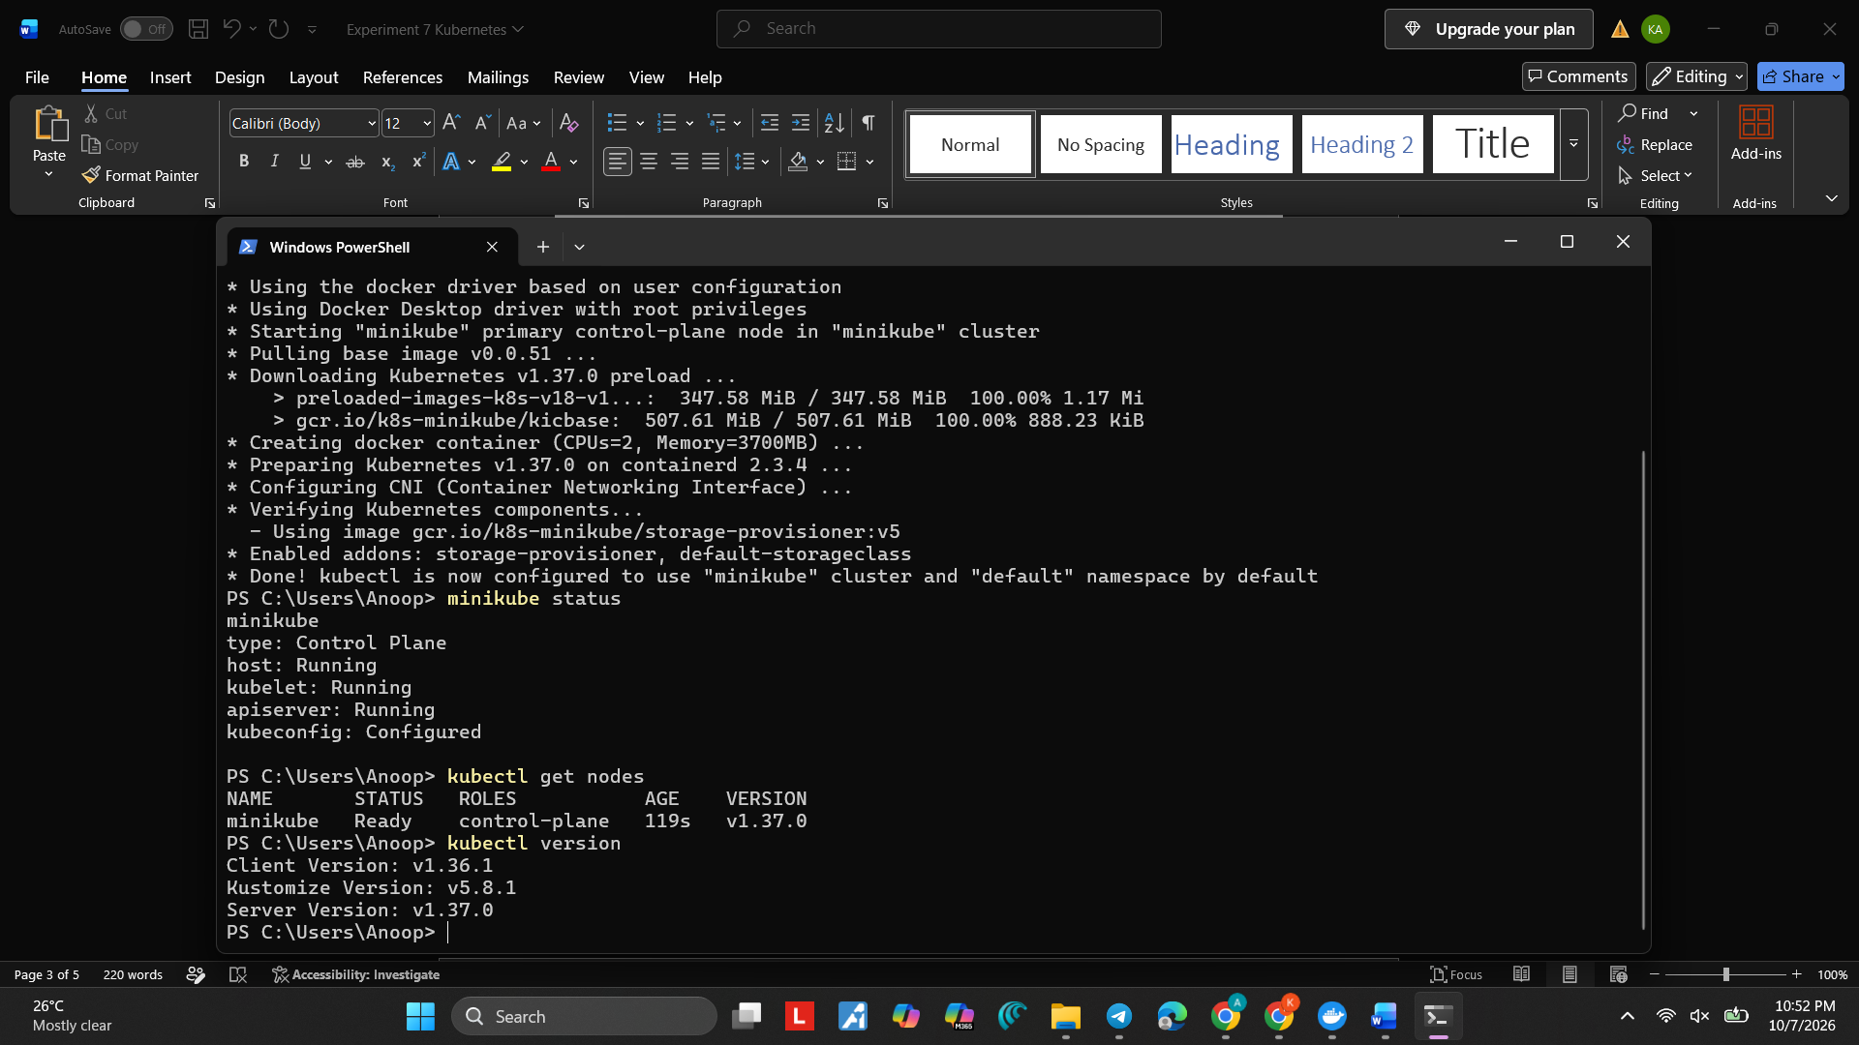

Step 3: Installation of POD
Goto web bowser and type Kubernetes pod
https://kubernetes.io/docs/concepts/workloads/pods/
Pod is basically a Yaml file
Copy the yaml code
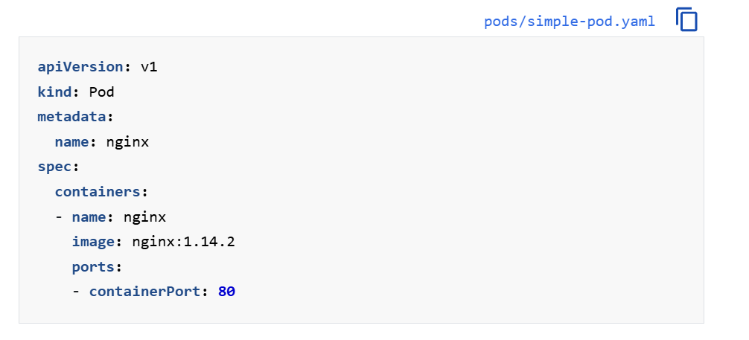
Cmd>vi pod.yml
Paste the code (if vi is not recognized)
Cmd> notepad pod.yaml
Click yes
Copy the code and Save the file and close Notepad.
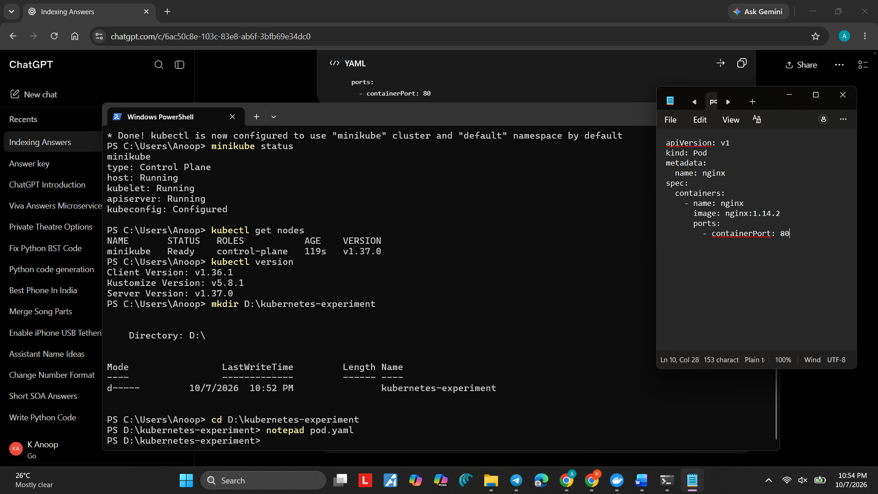
Deploy it:
Cmd> kubectl apply -f pod.yaml
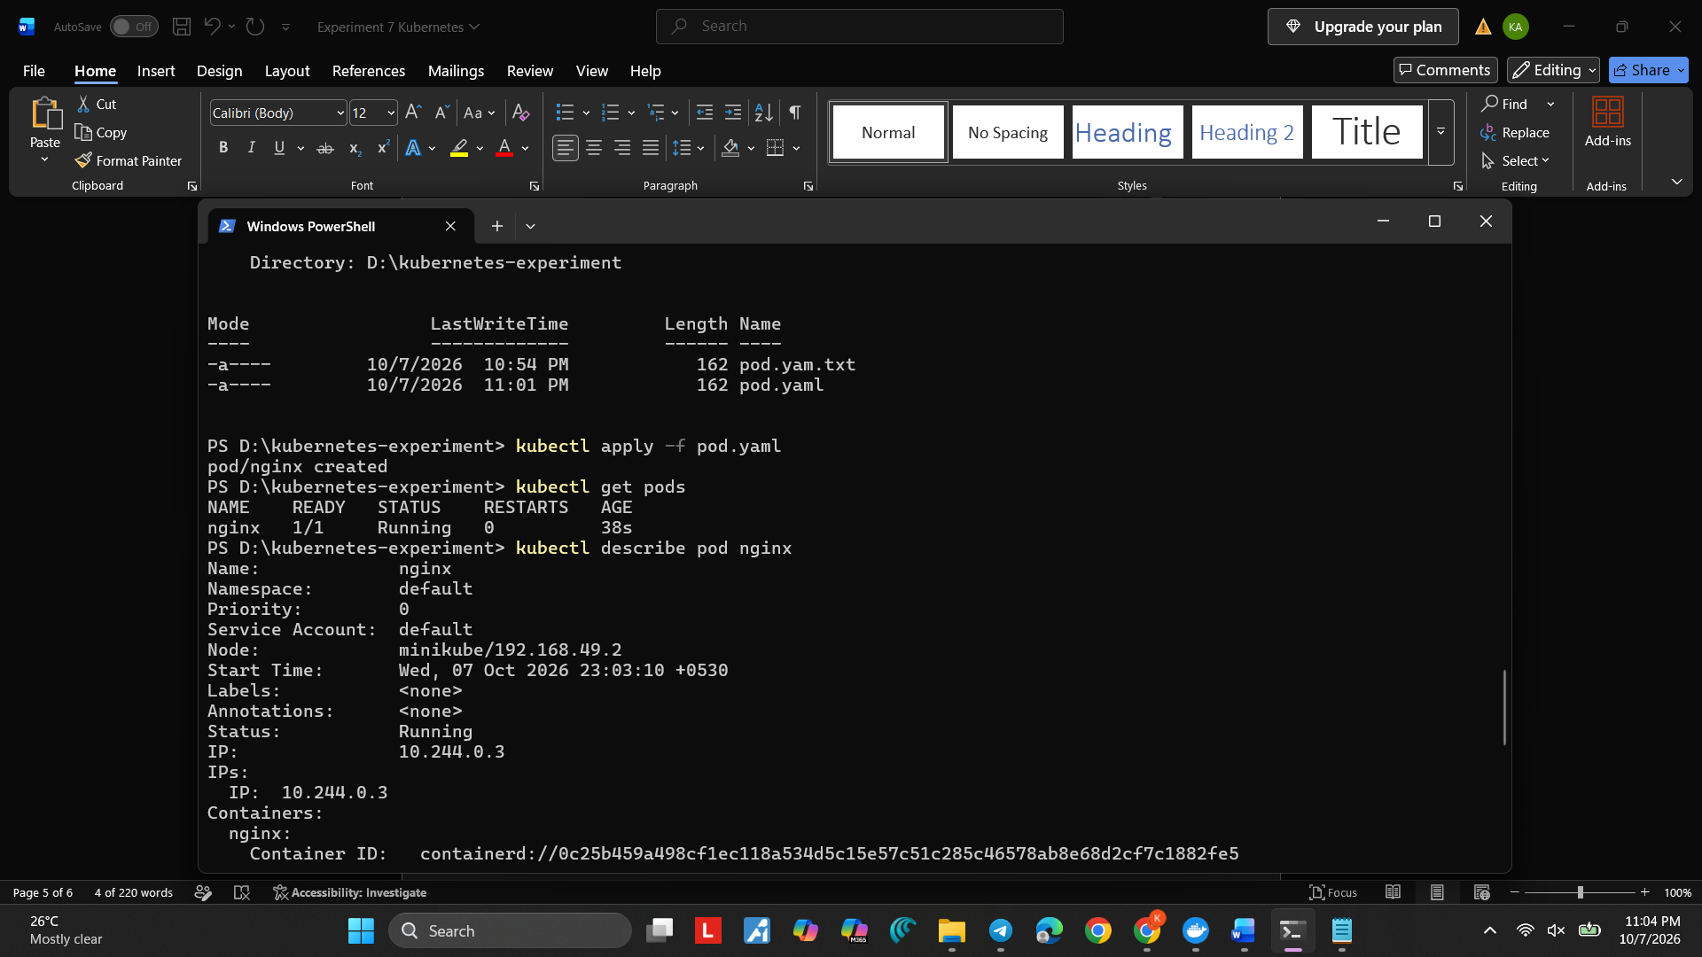
Verify the Pod
> kubectl get pods
Get Detailed Information
> kubectl describe pod nginx
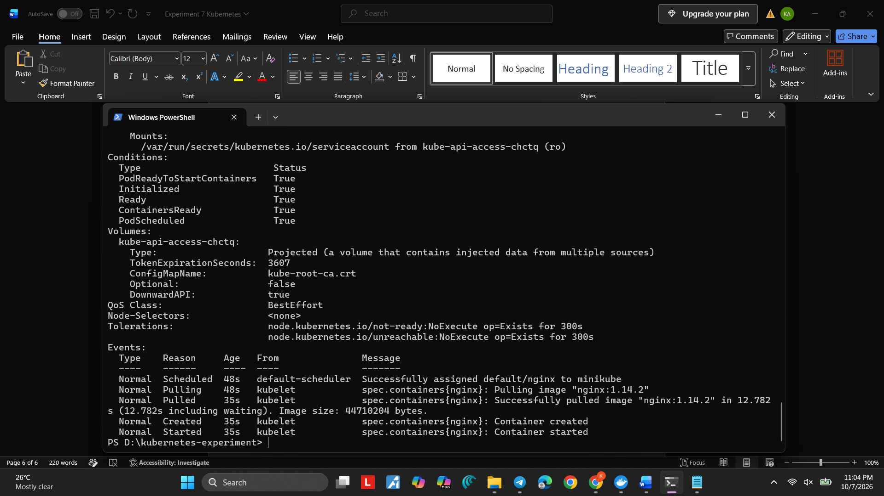
Access the Pod
kubectl port-forward nginx 8080:80
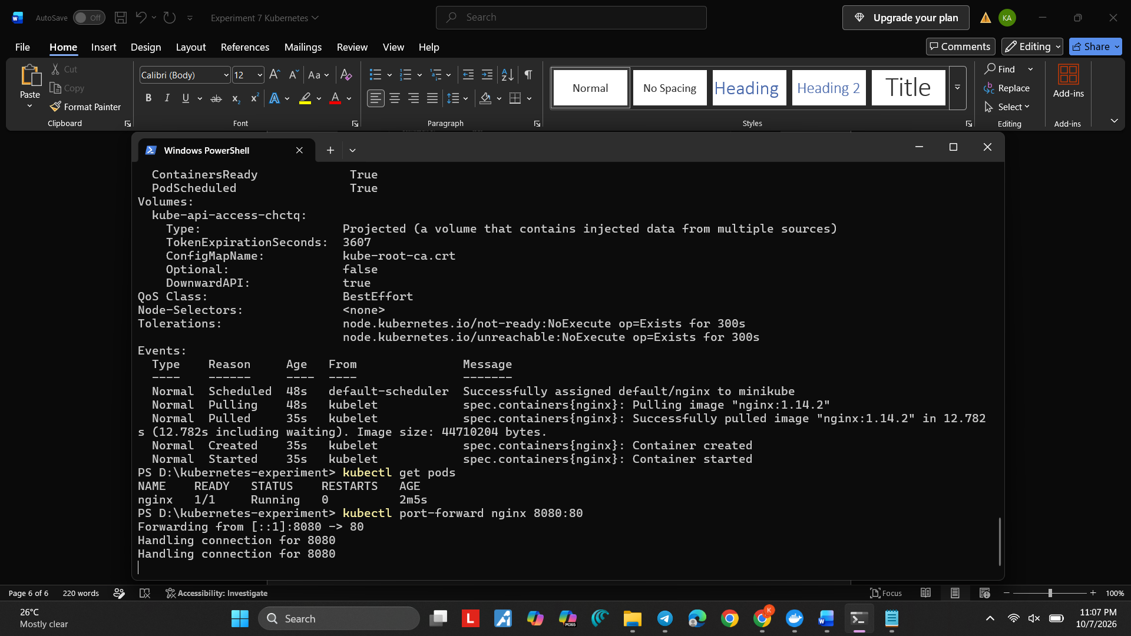
Output
Open a browser and visit:
http://localhost:8080
